National Honor Society Candidate

Documents 2021

**Please Read Carefully:**

**\*\*After reviewing the National Honor Society criteria *(in the Candidate Letter)* and if you would like to continue with the selection process, please read the “To Do List” below thoroughly and adhere to all deadlines. The information you provide to the NHS Selection Committee will aid in determining your eligibility for acceptance.**

**To Do List:** 

**Checklist of the Four Documents to create on the following pages:**

⬜ 1. Add a recent photograph of yourself to page 2



⬜ 2. Create and add a professional, typed, and updated resume to page 3



⬜ 3. Write an essay describing how you display **one or more** of the NHS criteria on page 4



*(character, service, leadership)*

⬜ 4. Fill out the Student Activities Form (2 pages) provided **(parent signatures required)**



On pages 5 & 6

*It is acceptable if your resume and essay extend beyond one page

How to submit this file:

Please upload this entire file (once all four documents are complete) using the following link: <https://forms.office.com/r/DFHLyJQ8cH>

DUE BY Friday, November 5

Document #1:

Insert a recent photograph of yourself on this page

(I am on the farthest right)

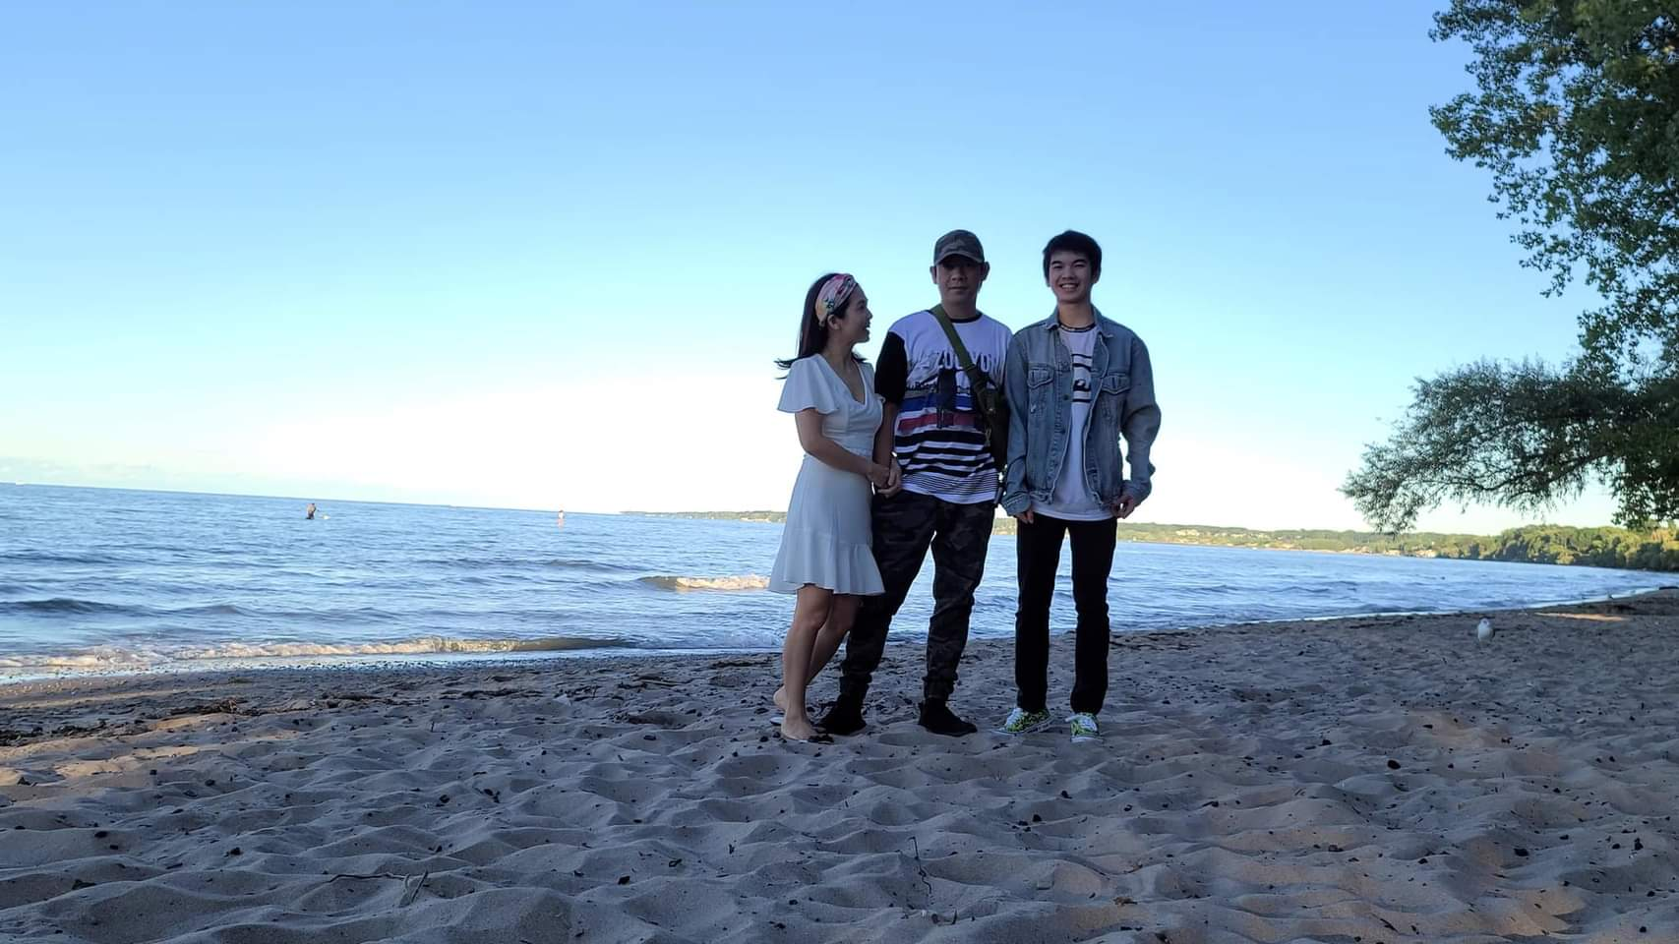

|  |  |
| --- | --- |
| Quang Huynh | (585) 351-4546  20378quang@gmail.com  16 Tarrycrest Lane  Rochester, NY 14606 |

Summary

An active, ambitious, and responsible high school junior with great communication and people skills. Displayed hard work, dedication, and determination through participation in extracurriculars, high grade reports, and volunteer work.

Skills

|  |  |  |
| --- | --- | --- |
| * Determined * Deadline-oriented * Quick learner * Great organizational skills * Good communication skills | * Enthusiastic * Works well under pressure * Works well under a team * Typing (90+ WPM) * CPR and First Aid Certified | * Leadership experience * Patience * Active listener * Time management * Attendance |

Experience

07/2021 – Present **Sales Associate**,Kohls – Rochester NY

* Helped and guided an average of 30 customers per shift in finding items and gave recommendations.
* Provided great customer service and has gotten 100% positive feedback during surveys.
* Replenished and organized products with efficiency. Responsible for completing tasks 20% faster than others in the Home and Kids department.
* Helped the company open 10 credits, which helped in bringing back customers.
* Took on extra shifts depending on the needs of the store.
* Trained new members how to operate machines and devices.

08/2019 – 09/2019 **Camp Counselor**, Gates Rec. – Rochester NY

* Ensured the safety of children.
* Cooperated with other adults and children.
* Organized and planned events.

06/2017 – 07/2019 **National Junior Honor Society**, GCMS – Rochester NY

* Maintained a consistent grade above 93% to keep membership.
* Participated in the Relay for Life event.

Educational Highlights

09/2019 - Present **Gates Chili High School** – Rochester NY

Junior

* + - * + GPA: 100.882 (Weighted)
        + Current holder of 4 High Honor Rolls (2019-Present)

09/2016 – 07/2019 **Gates Chili Middle School** – Rochester NY

* GPA: 96.451 (Unweighted)
* Holder of 16 High Honor Rolls (2016-2019)
* Academic Excellence in Music (2016)
* Academic Excellence in Chorus (2018)
* National Junior Honor Society (2017-2019)
* Music Student of the Month (2016)
* Spanish Student of the Month (2017)
* Technology Student of the Month (2018)

References

Kathryn White from Gates Chili High School

Kathryn_White@gateschili.org (585) 247-5050 ext. 72655

Julie Gangai from Gates Chili High School

juliegangai@gmail.com (585) 370-0460

Deborah Petricone from Kohls

dkennerknecht1@gmail.com [(585) 423-6545](https://www.searchpeoplefree.com/phone-lookup/585-423-6545)

Document #3:

On this page, write a creative essay describing how you display one or more of the NHS criteria *(character, service, leadership*).

*\*You may refer back to the first page of the “NHS Candidate Letter” for information about leadership, service and character.*

Ever since I was in elementary school and heard about the National Honors Society by a teacher, it has been always a goal of mine to join. I loved the idea of helping others, especially those who are in need. I’m extremely excited to be seen as a potential member of the National Honors Society organization. I believe that in becoming a member of the NHS, it would help me develop my skillset and grow as a person. I’m very determined and do not give up easily, taking on anything that comes my way to the best of my ability. Besides, although my GPA shows my academical success, I have done countless positive activities outside of school. As a student at the Gates Chili School District, there have been many instances where I’ve shown service, character, and leadership which I trust would let me join this prestigious and loving community.

When I was 12 years old, I had a stroke on my birthday in my bedroom. I remember this traumatic event very vividly. I was watching a YouTube video and all of a sudden, I felt as if a bullet got shot through my head. The world was spinning, and my body was numb. I ran to my dad, and he called 911. At the time, the only concern to me was my academics and scholarship. I was in the hospital and kept worrying about homework and all the information I was missing out on. Then, an MRI scan of my brain was performed, the doctors told me I had a blood clot on the right side of my brain, which affected the left side of my body. After that, the doctors did physical and mental examinations on me, which I had aced all of the math questions. It amazes me that I prioritized school and helping others than my own wellbeing during that period. My teachers came to the hospital to greet me and the first question I asked them was if there were any upcoming tests. Moreover, after my journey in the hospital, I had to do physical therapy. This was a long and painful process for me, as it was very difficult to move my body at the time. Everyday, I continued to do my daily physical therapy exercises through the pain, exhibiting my determination. I accepted that I can never fully recover from this incident, but I will listen to recommendations to help better myself. Even after that, I continued to participate in school events, sports, clubs, and volunteering. I’ve always been a nice person who respected everybody no matter what and followed the rules. But at that time, I developed my understanding of morality, value of people and the importance in time. I always tried to be in the shoes of others and see the other side, to see what people are going through. I realized that some people could be having a worse time than me. After that, I always shown a positive outlook and took time to understand others. I smiled and always tried made others laugh. I saw people for who they really were, celebrating the differences that everybody has and recognized the potential in everybody. I saw the importance of always doing my best to shape my future, along with the future of others.

I’ve helped my community by contributing my service through volunteering. For example, I volunteer to babysit children in special needs. I understand how difficult it is to take care of children who are disabled and/or impaired. I have a brother who has severe nonverbal autism and battled leukemia. Taking care of people with mental disabilities requires a lot of patience, awareness, and being consistent. Due to my good experience with taking care of kids with special needs, I was able to help family and locals with babysitting their children with mental disabilities. Furthermore, I helped my neighborhood to pick up trash and pick up dog waste people didn’t clean up. I love the feeling of being able to help the community and others since it really makes you feel good.

Furthermore, I display the traits of leadership through always being there to others when they need it. Whenever someone looks like they’re feeling down or need help, I am always there to help. I would tutor my classmates or friends when they ask. Furthermore, for my closest friends, I constantly remind them about upcoming assignments. I will admit, I do know my weaknesses and strengths. Thus, if I don’t know a subject that a peer is struggling on, I will try my absolute best to help them. Through learning the unknown and conquering my struggles, I can develop and grow as a scholar. No matter what, I am determined to help people and even if it takes taking hours to educate myself first, and then explaining the subject to them, I will.

With these skills, abilities and activities I’ve contributed towards my community, I believe I hold the requirements to be able to join the great National Honor Society. It always has been a dream of mine to join this society since I was a little kid. I enjoy the idea of having unlimited opportunities to assist others and continue to smile throughout the entire way. I am very grateful and honored to be considered a candidate for National Honor Society.

Document #4: Student Activities Form

**Name** Quang Huynh **Date entered Gates Chili HS** 9/11/2019

**Grade** 11

1. **SERVICE** - A non-paid, non-graded *(and not required for a class)* community or school activity such as: *helping Senior citizens, volunteering, cleaning neighborhood, church groups, peer tutoring, pep band, sports teams, clubs, scouts,* etc.

|  |  |  |  |  |  |
| --- | --- | --- | --- | --- | --- |
| **Activity** | **Grade(s)** | **In or Out of School** | **Hours of service**  **(specify per week/ and or per month)** | **Accomplishments** | **Contact Person**  ***(name & phone #)*** |
| Track and Field | 7-10 | In school | 10+ hours per week | 7.5 second 100m  17 feet covered in long distance  5 feet covered in high jump | Mr. Baker  Kyle_Baker@gateschili.org |
| Masterminds | 9-11 | In school | 8 hours per month | Competed against other schools in trivia and contributed to our school placing first | Mrs. Monaghan  Alison_Monaghan@gateschili.org |
| Yearbook Club | 8 | In school | 7 hours per week | Put together and designed section for sports | Mrs. DeGrave  Rebecca_DeGrave@gateschili.org |
| Gates Metros | 6-8 | Out of school | 12+ hours per week | Won several matches against other schools during games | Mr. Barrows  (585) 319-1272 |
| SOS Club | 8 | In school | 5 hours per week | Sang and performed the Star-Spangled Banner at Red Wings Stadium and Blue Cross Arena | Mrs. Ciarvella Julie_Ciarvella@gateschili.org |

1. **LEADERSHIP**- Any activity in which you hold the position or function of a leader (i.e. *sports team captain, club officer, troop leader, church groups, camp counselor,* etc.) without compensation such as money or academic credit.

|  |  |  |  |  |  |  |
| --- | --- | --- | --- | --- | --- | --- |
| **Activity** | **Grade(s)** | **Leadership Role or position** | **In or Out of School** | **How many Hours per week/per month?** | **Tasks/Accomplishments** | **Contact Person**  ***(name & phone #)*** |
| Summer Camp | 9th | Camp Counselor | Out | 10+ hours per week | Supervised children and cooperated with adults. | Gates Rec.  (585) 429-8289 |
| Soccer | 8th | Team Captain | In | 11+ hours per week | Acted as a role model for the team and encouraged the team to improve. | Mr. Baker  Kyle_Baker@gateschili.org |
| Delta Sonic Fundraiser | 8th | Organizer | Out | 3 hours per week | Organized fundraiser campaign for my soccer team  Washed cars earn money to donate to people in need | Mr. Barrows  (585) 319-1272 |
| Car washing | 11th | Organizer | Out | 4+ hours per week | Designed a logo for company  Handed fliers  Washed cars for free during the summer | Mr. Lam  (585) 260-2065 |

**❑ I have read this form and can verify its complete authenticity.**



\*\***Parent/Guardian Signature: _____________________________________________________ Date 10/25/21**



**❑ I have honestly and accurately completed this form to the best of my ability and understand that completion of this form does not guarantee membership to the High School Gates Chili National Honor Society.**

**\*\*Student Signature: _______________________________________________________________ Date 10/25/21**

